SENSOR

PH

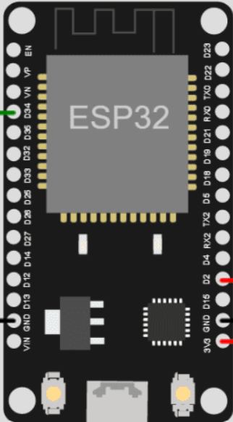

To

Do

Po

G

G

VCC

VCC

GND

AO

SENSOR

TURBIDEZ